HW2a

YL5090

Yuqiong Li

SEG3- Write up

# **Preprocessing:**

1. Order the speed data as time
2. Remove outliers
   1. This step is done by removing all points that are 3 standard deviation away from sample mean.
3. For NaN values, fill it with the last valid value before it
4. The circle of seasonality is 144. Remove seasonality by subtracting the value 144 time stamp away. Then remove the first 144 values as they are nan now.

Identification:

After cleaning data, now identify an ARIMA(p, d, q) model.

Step 1: First plot the time-series



After differentiating:



Use the Augmented Dickey-Fuller test to check existence of unit root:

ADF statistic: -12.984187

p-value: 0.000000

Critical Values:

1%: -3.431

5%: -2.862

10%: -2.567

Conclusion:

1. Differentiated data doesn’t seem to fit any upward or downward trend.
2. Augmented Dickey-Fuller test rejects null hypothesis. Thus no unit root. No time dependent structure.
3. Thus, now conclude stationary. Set d = 0.

# Step 2: Identify AR or MA process by plotting ACF and PACF for different lag values.

Observations: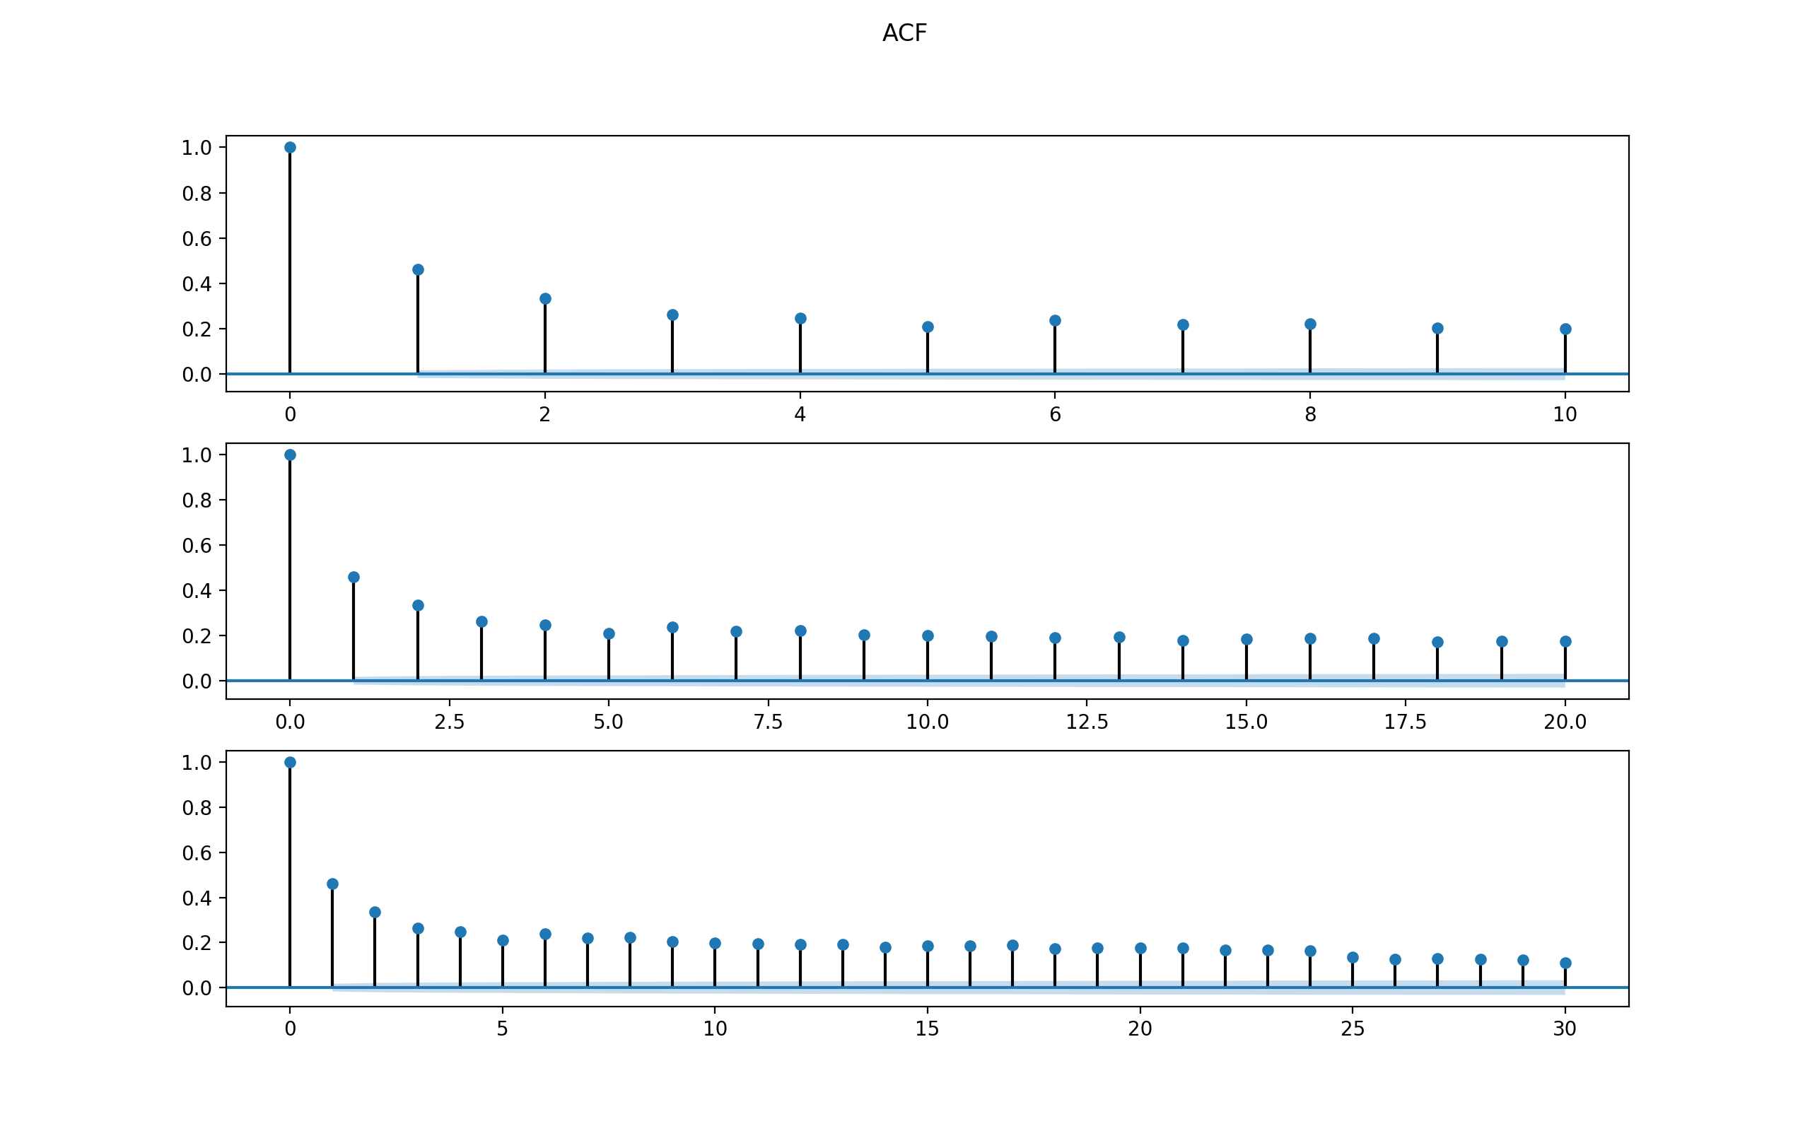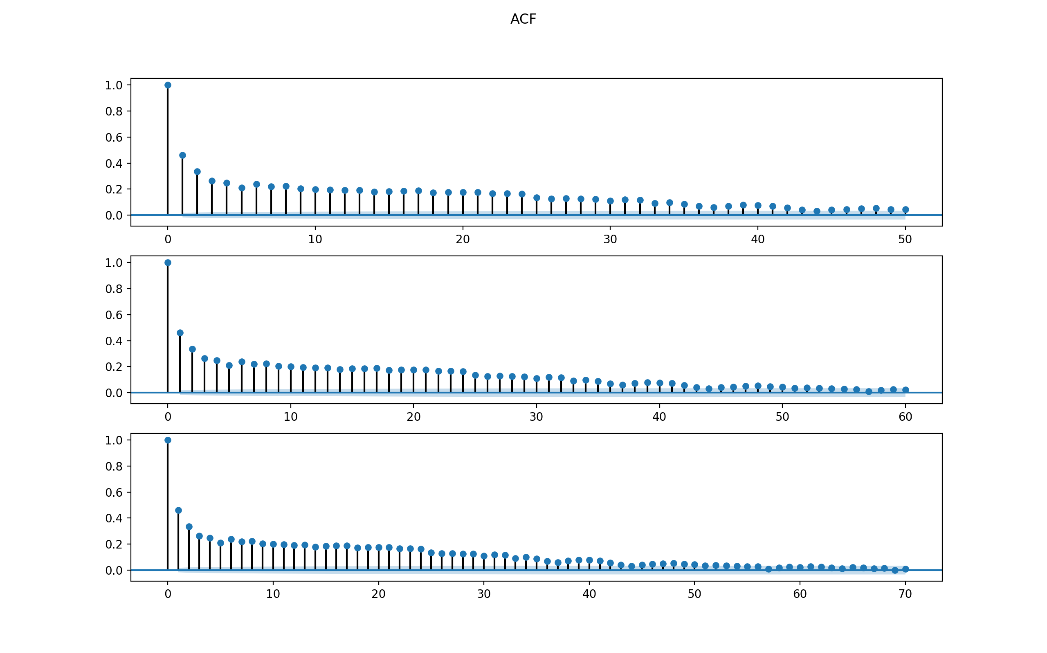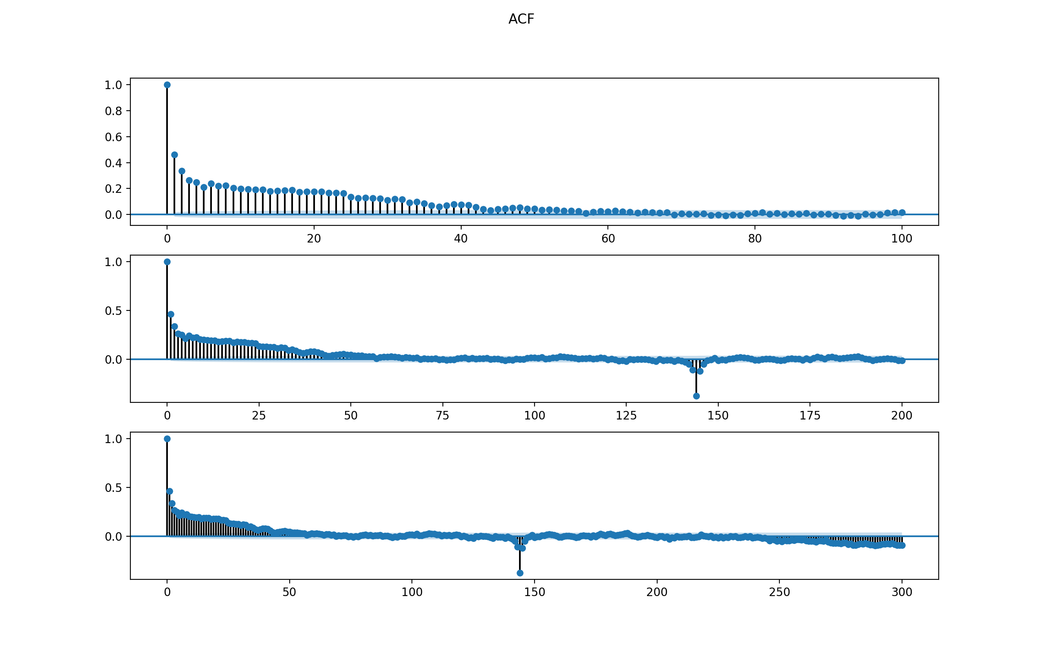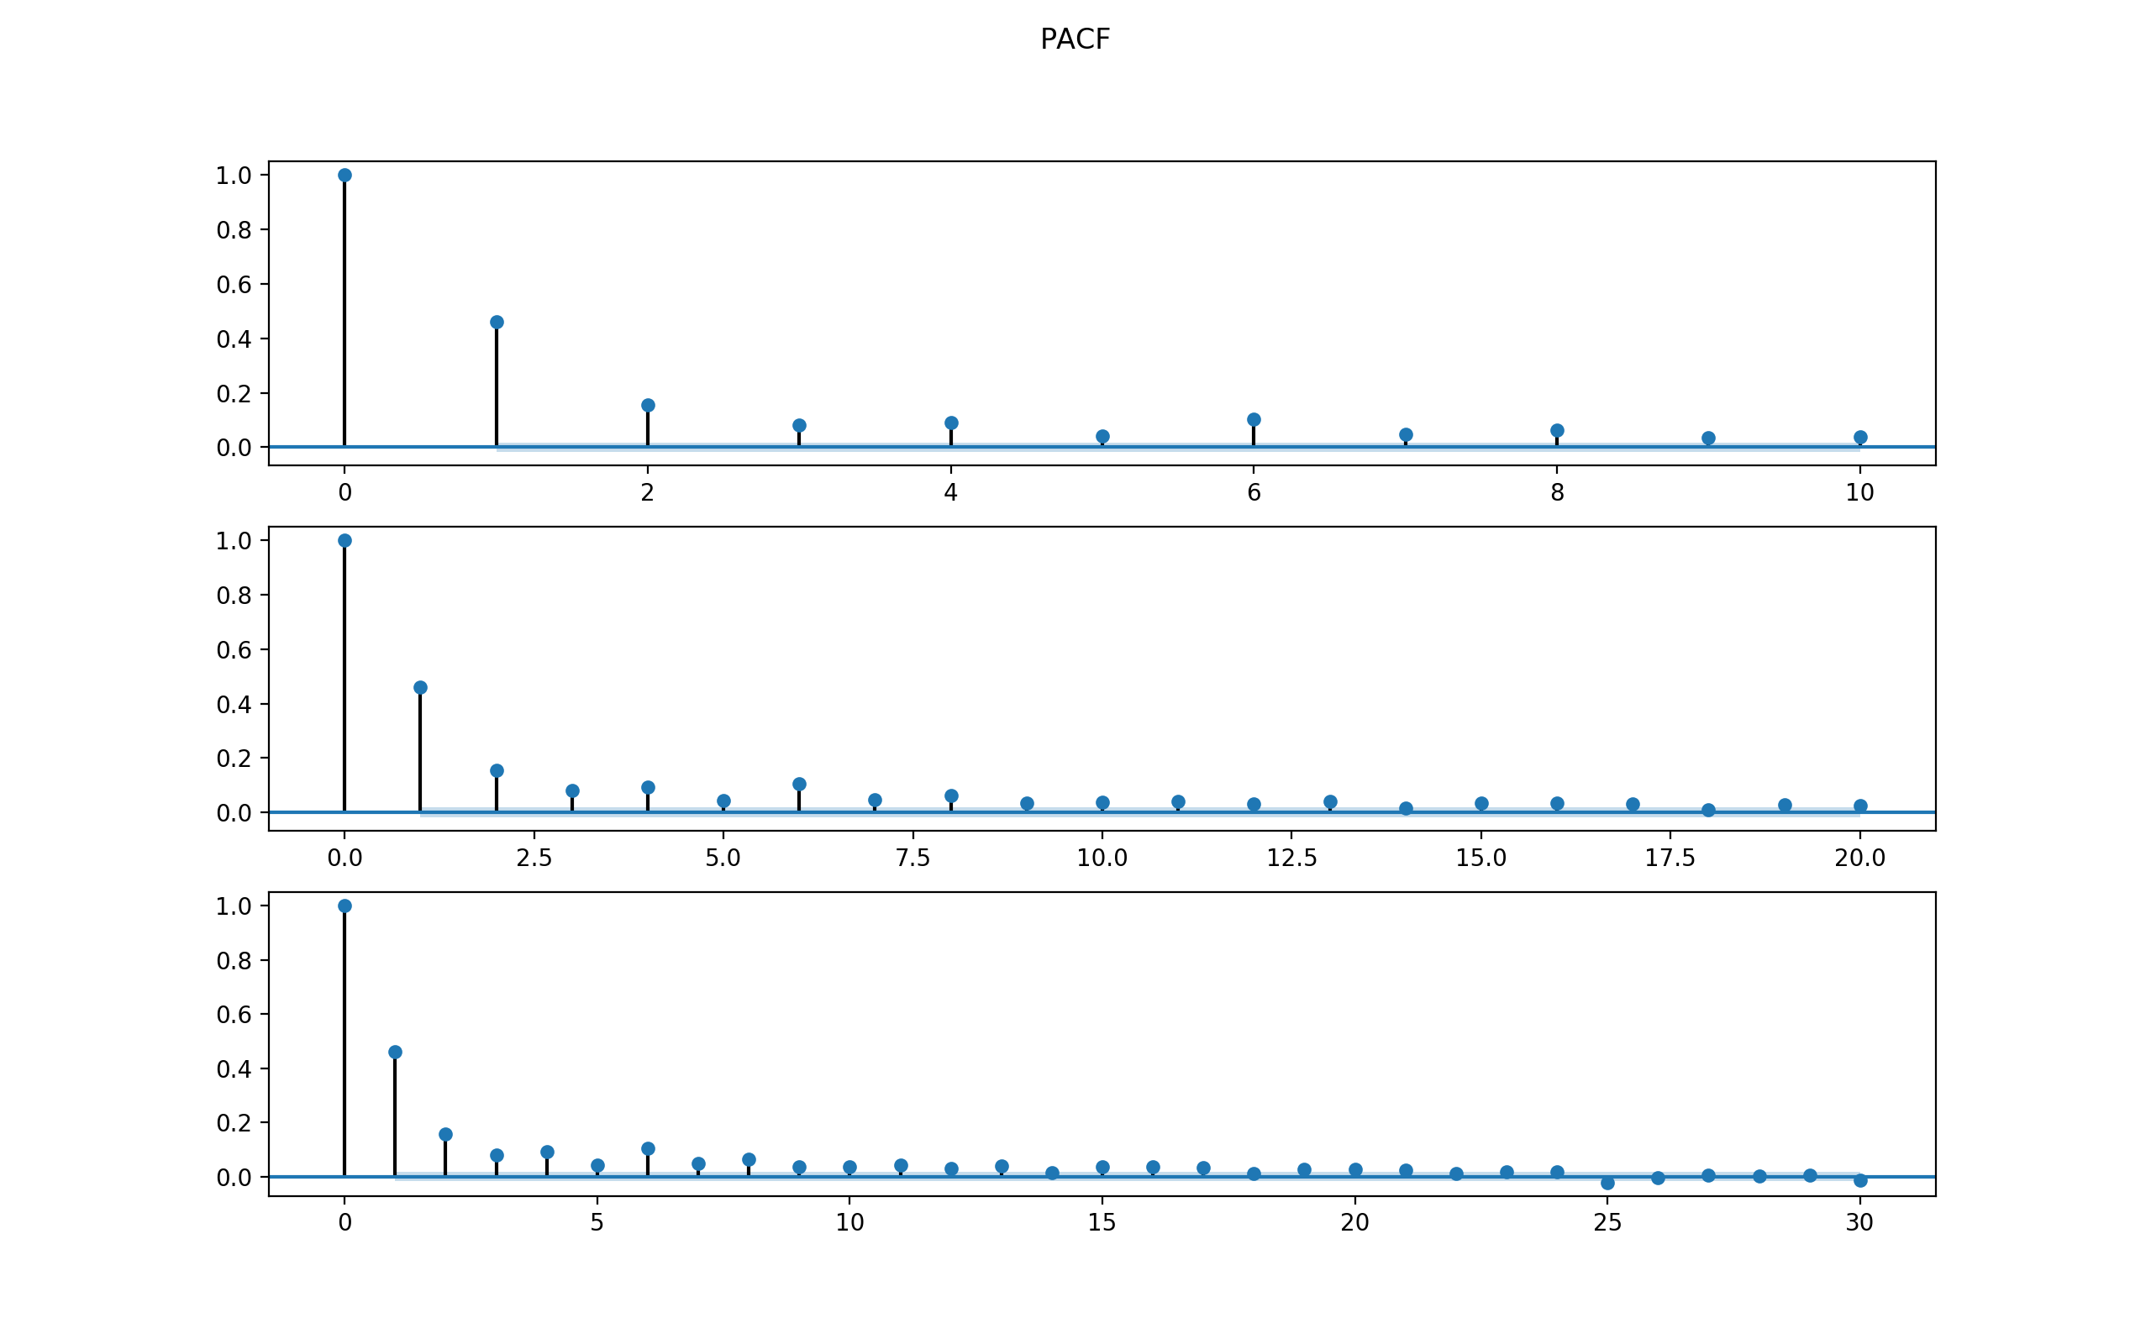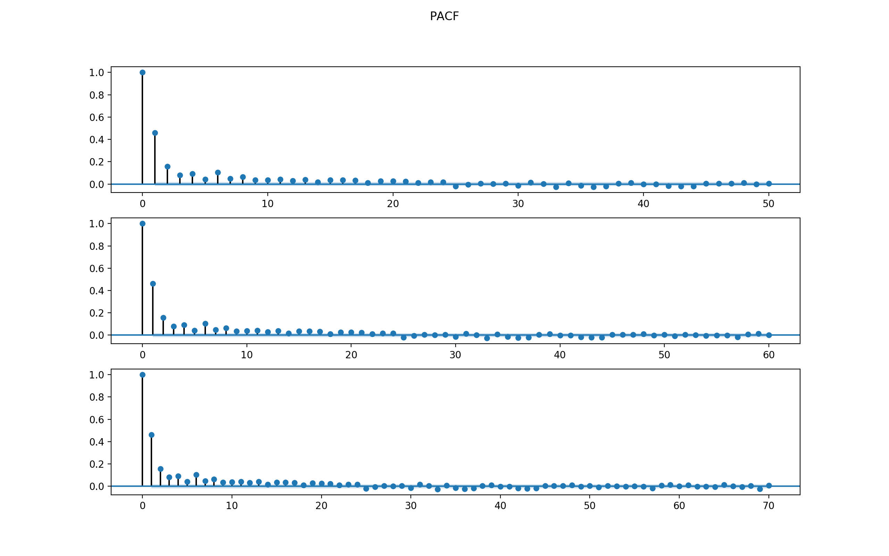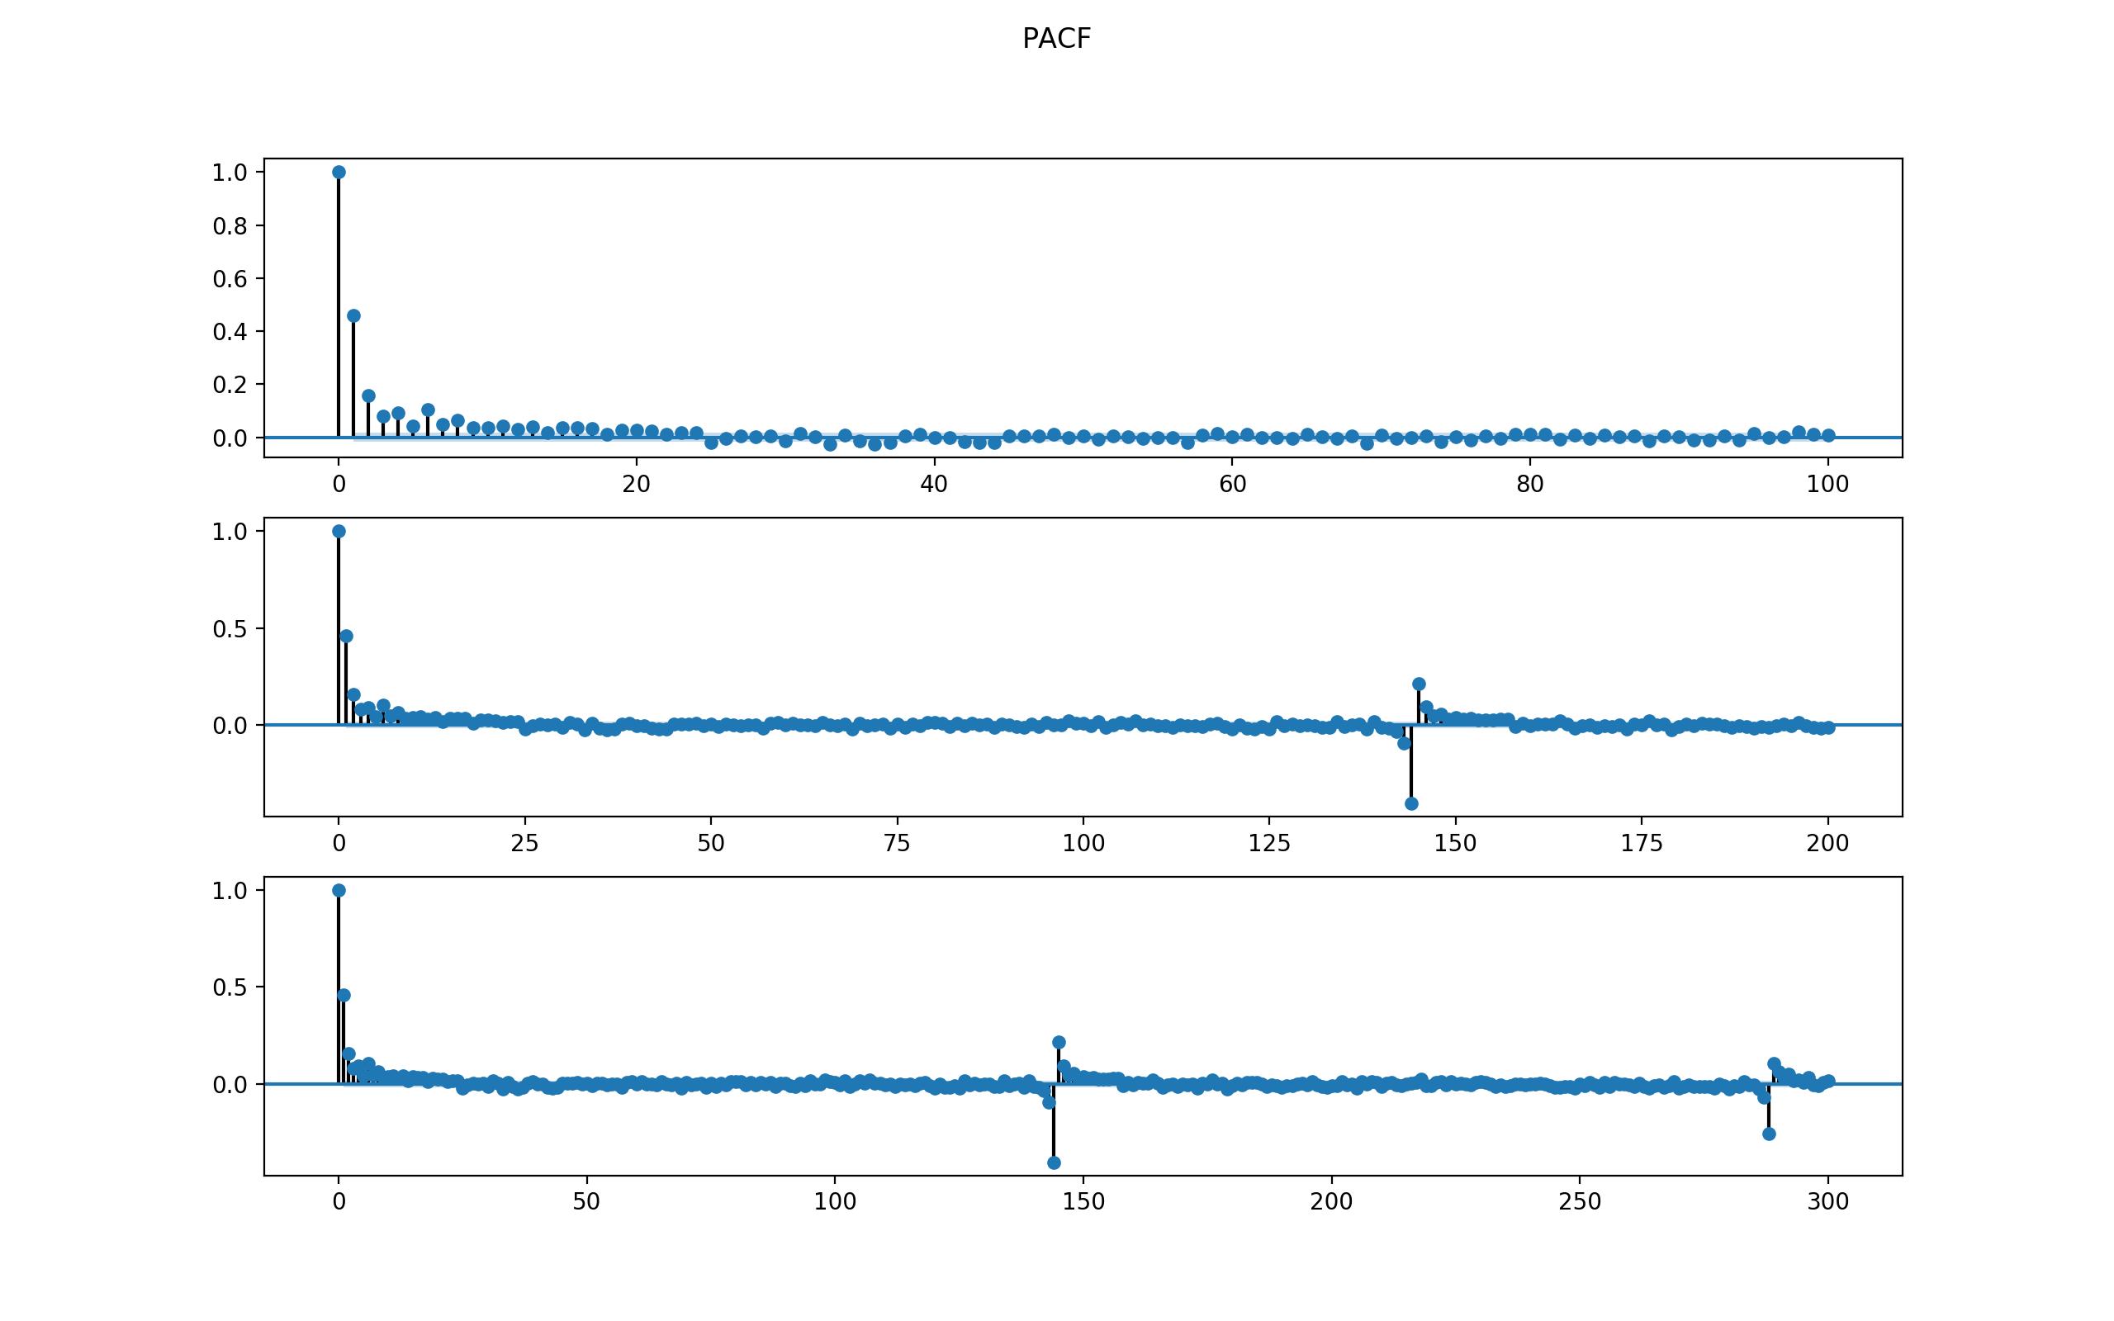

1. ACF dies off after lag 42 or so.
2. PACF dies off after lag 9 or so.

Thus, the model might be an AR(42), MA(9), or a mixture of ARMA. Test all possible p from 1 to 42, q from 1 to 9, and combination of (p, p) from this range.

ARMA Model Results

==============================================================================

Dep. Variable: Speed No. Observations: 8544

Model: ARMA(11, 0) Log Likelihood -14471.587

Method: css-mle S.D. of innovations 1.316

Date: Mon, 11 Dec 2017 AIC 28969.174

Time: 16:10:27 BIC 29060.862

Sample: 08-02-2014 HQIC 29000.454

- 09-30-2014

================================================================================

coef std err z P>|z| [0.025 0.975]

--------------------------------------------------------------------------------

const -0.0074 0.053 -0.141 0.888 -0.110 0.096

ar.L1.Speed 0.3656 0.011 33.823 0.000 0.344 0.387

ar.L2.Speed 0.0946 0.012 8.218 0.000 0.072 0.117

ar.L3.Speed 0.0208 0.012 1.803 0.071 -0.002 0.043

ar.L4.Speed 0.0608 0.012 5.270 0.000 0.038 0.083

ar.L5.Speed -0.0262 0.012 -2.269 0.023 -0.049 -0.004

ar.L6.Speed 0.0868 0.012 7.529 0.000 0.064 0.109

ar.L7.Speed -0.0029 0.012 -0.247 0.805 -0.026 0.020

ar.L8.Speed 0.0516 0.012 4.468 0.000 0.029 0.074

ar.L9.Speed 0.0225 0.012 1.943 0.052 -0.000 0.045

ar.L10.Speed 0.0098 0.012 0.852 0.394 -0.013 0.032

ar.L11.Speed 0.0459 0.011 4.233 0.000 0.025 0.067

Roots

==============================================================================

Real Imaginary Modulus Frequency

------------------------------------------------------------------------------

AR.1 1.0859 -0.0000j 1.0859 -0.0000

AR.2 1.0617 -0.7183j 1.2819 -0.0947

AR.3 1.0617 +0.7183j 1.2819 0.0947

AR.4 0.6128 -1.2310j 1.3750 -0.1765

AR.5 0.6128 +1.2310j 1.3750 0.1765

AR.6 -0.1493 -1.3698j 1.3780 -0.2673

AR.7 -0.1493 +1.3698j 1.3780 0.2673

AR.8 -0.8196 -1.0526j 1.3340 -0.3553

AR.9 -0.8196 +1.0526j 1.3340 0.3553

AR.10 -1.3555 -0.2742j 1.3830 -0.4682

AR.11 -1.3555 +0.2742j 1.3830 0.4682

ARMA Model Results

==============================================================================

Dep. Variable: Speed No. Observations: 8544

Model: ARMA(0, 8) Log Likelihood -14567.997

Method: css-mle S.D. of innovations 1.331

Date: Mon, 11 Dec 2017 AIC 29155.994

Time: 16:29:46 BIC 29226.524

Sample: 08-02-2014 HQIC 29180.056

- 09-30-2014

===============================================================================

coef std err z P>|z| [0.025 0.975]

-------------------------------------------------------------------------------

const -0.0066 0.033 -0.204 0.839 -0.070 0.057

ma.L1.Speed 0.3815 0.011 35.117 0.000 0.360 0.403

ma.L2.Speed 0.2465 0.012 21.160 0.000 0.224 0.269

ma.L3.Speed 0.1522 0.012 12.760 0.000 0.129 0.176

ma.L4.Speed 0.1504 0.012 12.833 0.000 0.127 0.173

ma.L5.Speed 0.0658 0.011 5.936 0.000 0.044 0.087

ma.L6.Speed 0.1233 0.011 11.179 0.000 0.102 0.145

ma.L7.Speed 0.0639 0.011 5.751 0.000 0.042 0.086

ma.L8.Speed 0.0760 0.011 7.161 0.000 0.055 0.097

Roots

=============================================================================

Real Imaginary Modulus Frequency

-----------------------------------------------------------------------------

MA.1 1.1096 -0.7419j 1.3347 -0.0938

MA.2 1.1096 +0.7419j 1.3347 0.0938

MA.3 0.3185 -1.3505j 1.3875 -0.2131

MA.4 0.3185 +1.3505j 1.3875 0.2131

MA.5 -1.1961 -0.5737j 1.3266 -0.4288

MA.6 -1.1961 +0.5737j 1.3266 0.4288

MA.7 -0.6529 -1.3247j 1.4768 -0.3229

MA.8 -0.6529 +1.3247j 1.4768 0.3229

ARMA Model Results

==============================================================================

Dep. Variable: Speed No. Observations: 8544

Model: ARMA(1, 6) Log Likelihood -14456.180

Method: css-mle S.D. of innovations 1.314

Date: Mon, 11 Dec 2017 AIC 28930.361

Time: 16:30:26 BIC 28993.838

Sample: 08-02-2014 HQIC 28952.016

- 09-30-2014

===============================================================================

coef std err z P>|z| [0.025 0.975]

-------------------------------------------------------------------------------

const -0.0090 0.068 -0.132 0.895 -0.143 0.125

ar.L1.Speed 0.9662 0.005 187.006 0.000 0.956 0.976

ma.L1.Speed -0.6062 0.012 -50.534 0.000 -0.630 -0.583

ma.L2.Speed -0.1306 0.013 -10.205 0.000 -0.156 -0.106

ma.L3.Speed -0.0807 0.013 -6.356 0.000 -0.106 -0.056

ma.L4.Speed 0.0005 0.012 0.038 0.969 -0.023 0.024

ma.L5.Speed -0.0741 0.013 -5.831 0.000 -0.099 -0.049

ma.L6.Speed 0.0542 0.011 4.919 0.000 0.033 0.076

Roots

=============================================================================

Real Imaginary Modulus Frequency

-----------------------------------------------------------------------------

AR.1 1.0350 +0.0000j 1.0350 0.0000

MA.1 -1.3037 -0.9505j 1.6134 -0.3997

MA.2 -1.3037 +0.9505j 1.6134 0.3997

MA.3 0.3734 -1.6859j 1.7268 -0.2153

MA.4 0.3734 +1.6859j 1.7268 0.2153

MA.5 1.1372 -0.0000j 1.1372 -0.0000

MA.6 2.0920 -0.0000j 2.0920 -0.0000

-----------------------------------------------------------------------------

The final chosen model is ARMA(1, 6) because 1) the PACF supports and AR(1) and 2) it has smallest BIC compared to other models.

Check the residuals to see if the model makes sense.

For ARMA(1, 6) model for SEG1, the 4-plot of residuals are below.

The MSE is 7377.035662374872. Seems to be a good fit compared to other modelling segments.

The conclusion is that the residuals are not normal. Thus ARMA(1) might not be a good fit.

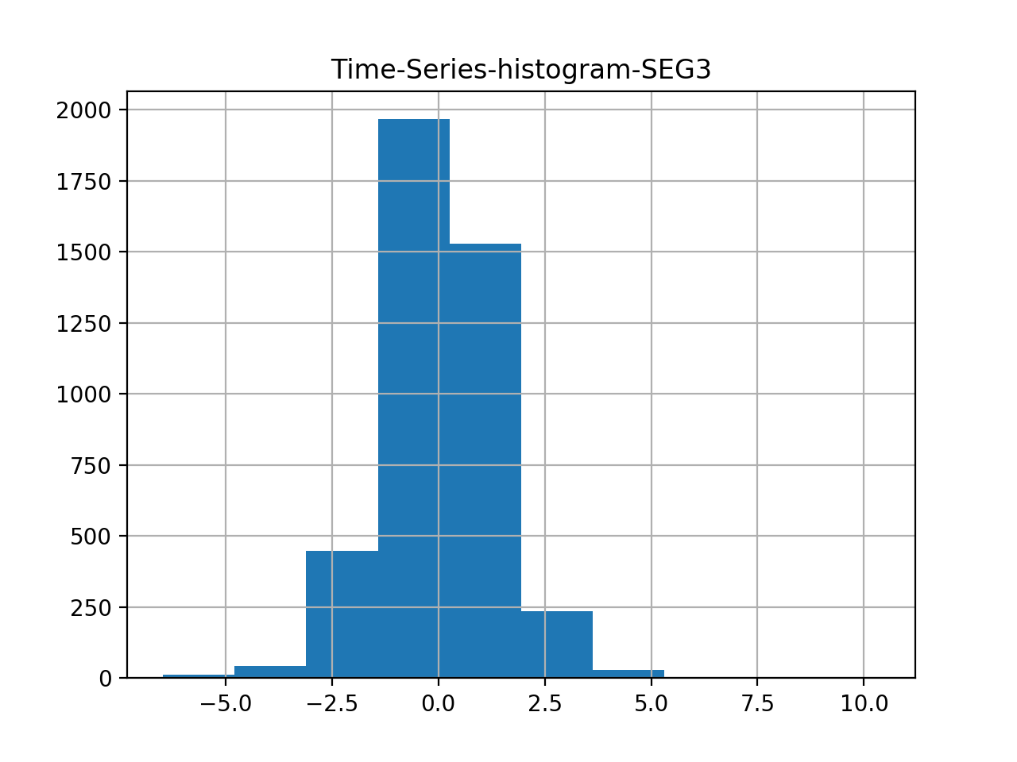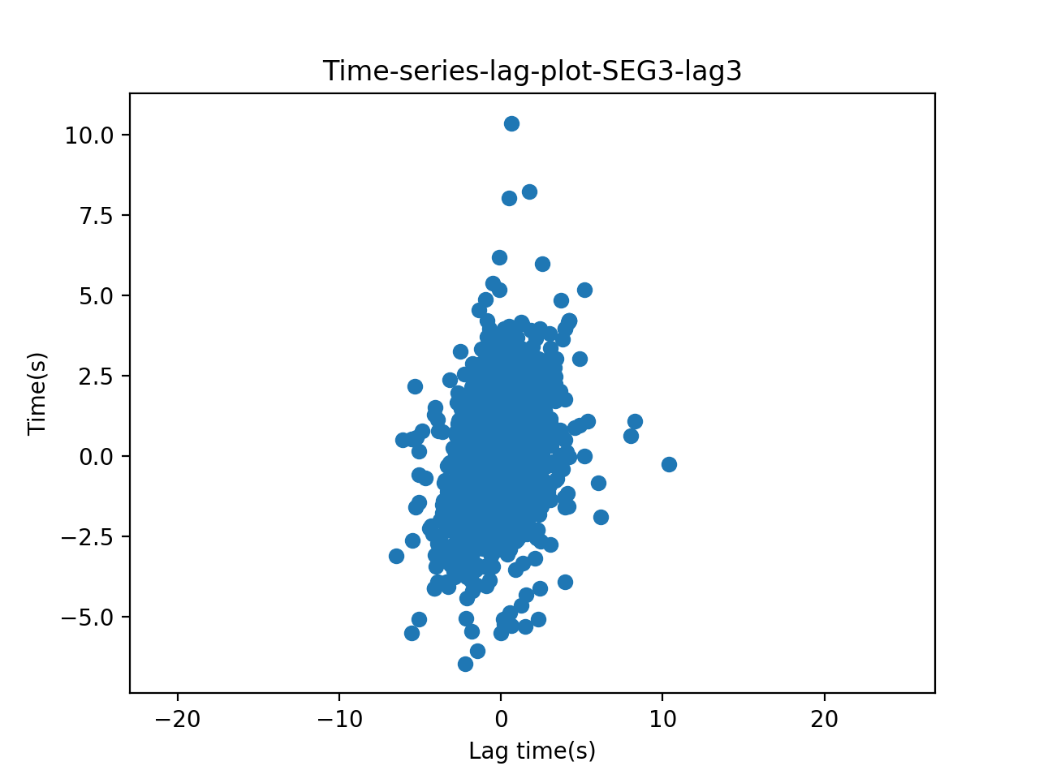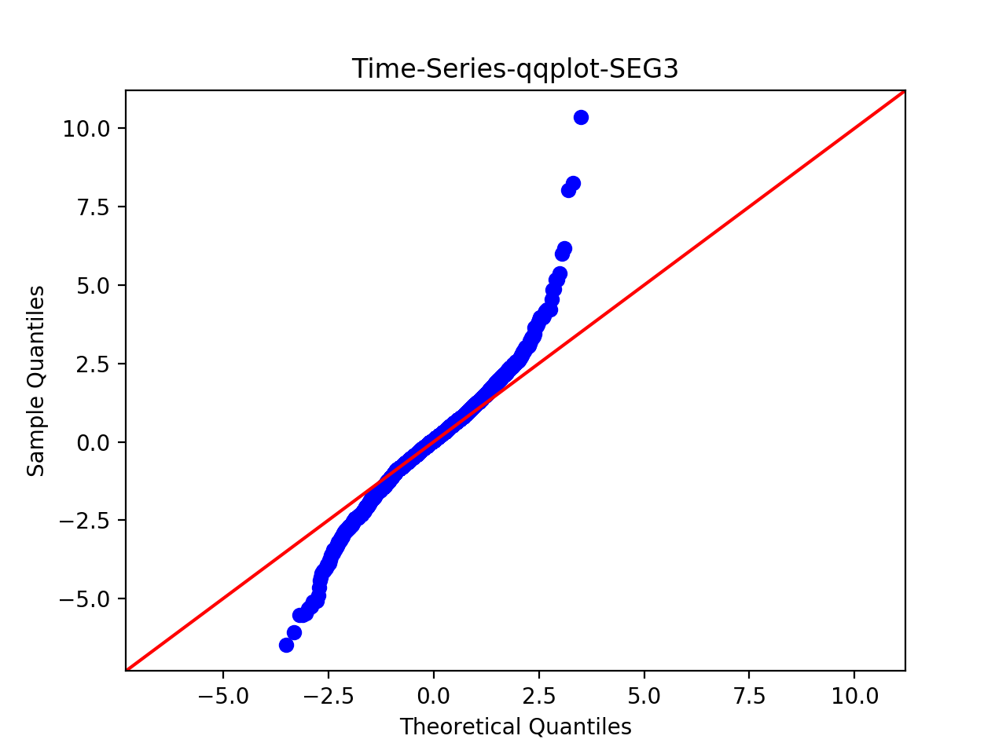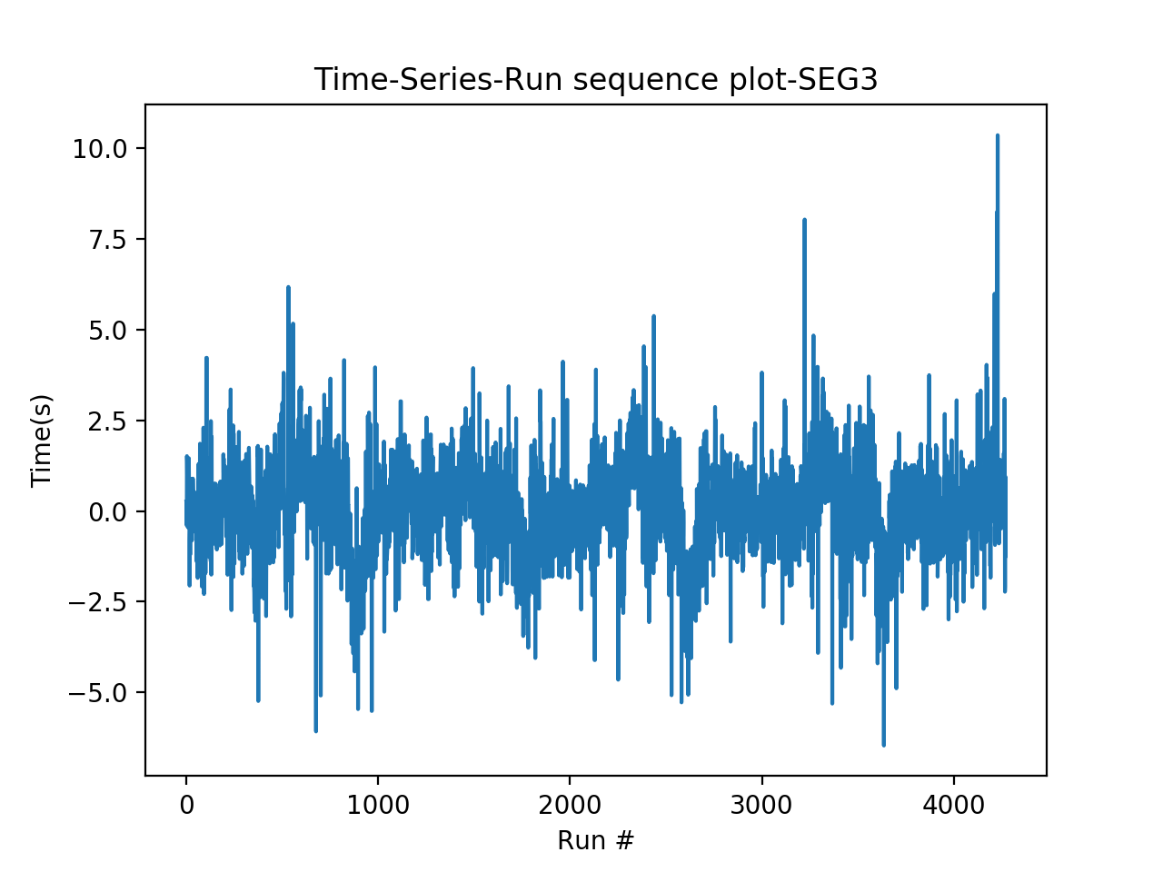

Use Chi-square goodness of fit and set number of bins = 200, results:

Power_divergenceResult(statistic=29192.993206840008, pvalue=0.0)

The p-value is smaller than 0.05, thus reject null. Thus there is a significant difference between the two data series – thus this model is not a good fit.

# Step 3: Test for OLS regression model, using mllib.

Data transformation: to run regression, since previous fit an AR(1) model, now use past day’s value as features.

For training data, the mean Squared Error = 1.8367502616

For test data, Mean Squared Error = 1.38805188004

This seems to be a good fit.

Thus, use MLlib for chi-square test returns the following results:

>>> pearson.pValue

0.0

>>> pearson.statistic

inf

Conclude that regression on a single past value is not a good fit, but the MSE value is small.

# Step 4: Test for Ridge regression model, using mllib.

Again using past three day’s value as feature.

For training data, the mean Squared Error = 1.8367502616

For test data, Mean Squared Error = 1.38805188004

The goodness of fit value:

>>> pearson.pValue

0.0

>>> pearson.statistic

inf

Conclude that ridge regression on a single past value is also not a good fit, although the MSE values are small.

# Step 5: Test for Lasso regression model, using mllib.

Again using past three day’s value as feature.

For training data, the mean Squared Error = 1.8367502616

For test data, Mean Squared Error = 1.38805188004

Thus, use MLlib for chi-square test returns the following results:

>>> pearson.pValue

0.0

>>> pearson.statistic

inf

Conclude that Lasso regression on a single past value is also not a good fit.

Conclusion for Step 3 – Step 5:

Ridge, OLS, and Lasso seem to generate similar results. The MSE for test set is 1.38805188004

AR(1) model, the MSE for test data is 7377.035662374872.